ASSIGNMENT SOLUTION

# 3RD FEBRUARY

Q1: Which keyword is used to create a function? Create a function to return a list of odd numbers in the

range of 1 to 25.

ANS: DEF is a keyword used to create a function.

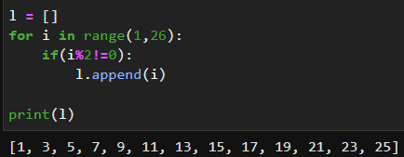

Q2: Why *args and **kwargs is used in some functions? Create a function each for *args and **kwargs

to demonstrate their use.

ANS: *args and **kwargs are used in functions as a way to pass a variable number of arguments to the function. The single asterisk * is used to pass a variable number of non-keyword arguments to a function, while a double asterisk ** is used to pass a variable number of keyword arguments

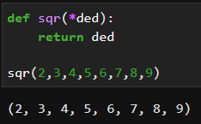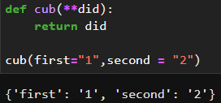

Q3: What is an iterator in python? Name the method used to initialise the iterator object and the method

used for iteration. Use these methods to print the first five elements of the given list].

ANS : The __iter__ method returns the iterator object and the __next__ method returns the next value in the iteration.

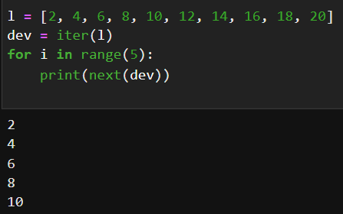

Q4: What is a generator function in python? Why yield keyword is used? Give an example of a generator

function.

ANS: A generator function in Python is a function that uses the yield keyword instead of the return keyword to return a value. When a generator function is called, it returns a generator object that can be iterated over using a for loop or the next() function.

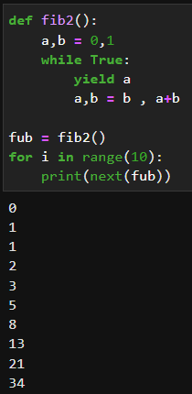

Q5: Create a generator function for prime numbers less than 1000. Use the next() method to print the

first 20 prime numbers.

ANS : 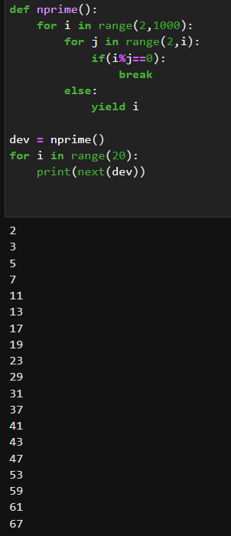

Q6: Write a python program to print the first 10 Fibonacci numbers using a while loop.

ANS : 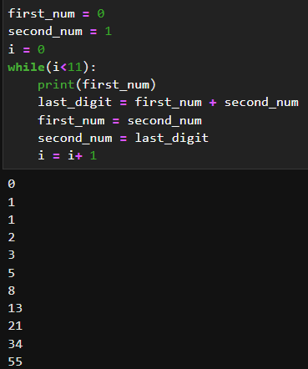

Q7: Write a List Comprehension to iterate through the given string: ‘pwskills’.

Expected output: ['p', 'w', 's', 'k', 'i', 'l', 'l', 's']

ANS: 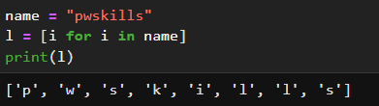

Q8 : Write a python program to check whether a given number is Palindrome or not using a while loop.

ANS: 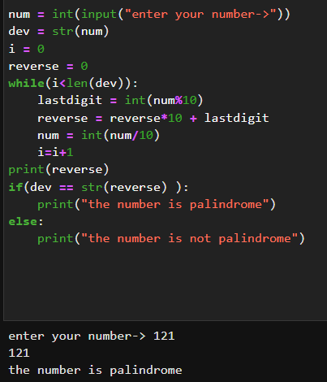

Q9: Write a code to print odd numbers from 1 to 100 using list comprehension.

ANS: 